Cemetery Interpretation Plan
Montgomery, AL

Synthesis Studio 2
Michaela Bostick

Table of Contents

Executive Summary …………………………………………………………………………… 3
History ………………………………………………………………………………………… 3-4
Inventory/Data ………………………………………………………………………………… 4-8
Sites …………………………………………………………………………………………… 4
Goals …………………………………………………………………………………………... 8
Objectives ……………………………………………………………………………………... 8-9
Audiences ……………………………………………………………………………………… 9
Interpretation Proposal …………....………………………………………………………… 9-14
Recommendations ……………………………………………………………………...........14
Budget ……………………………………………………………………………………… 15-16
Conclusions …………………………………………………………………………………. 16
Appendices……………………………………………………………………….………… 17- 30
Appendix 1- Interpretation Examples…………………………..…………………………… 18-22
Appendix 2 - Recommendations……………………………………………………………. 23-24
Appendix 3 – Oakwood Cemetery Notable Graves…………………………...……………. 25-26
Appendix 4 – Greenwood Cemetery Notable Graves …………………………..…………….. 27
Appendix 5 – Lincoln Cemetery Notable Graves ....................................................................... 28
Appendix 6 – Montgomery, AL cemetery list ...................…………………………………. 29-30
Sources ……………………………………………………………………………………… 31-32

Executive Summary
An interpretative plan is a foundational document that helps museums and historical institutions tell their stories, interpret their resources and achieve their overall missions. It functions as a guide for planning and targeting programming and community engagement activities by setting out specific objectives and desirable outcomes.
Being tasked with creating an interpretive plan for the Overall History of the City of Montgomery, AL, what other place is more rich in history than the cemeteries? In choosing to focus on the cemeteries in Montgomery, this plan is able to focus on the history of those that have come before us. In Montgomery, AL there are 37 total cemeteries, some are compliant and some are non-compliant (see Appendix 6 for full list of cemeteries). Within these cemeteries lie historic figures and centuries of history that should be shared with the public.

History
During the 19th century, before parks were established, people would use cemeteries as their recreation spaces. Today, they are used to reflect on the history of those that lie within. From the outside looking in, we would think the tombstones only reflect the words that are written on them. But they tell us so much more than that! A deep dive into data collection (Appendix 2.1) we can learn about a person’s class, status, gender, reputation, race, etc. simply by the size, shape, material, placement, remarks, and abbreviations on the tombstone. With this plan, visitors and community members will have the opportunity to take a deeper look into the life stories of these people that have been laid to rest within these cemeteries.
Montgomery’s first city cemetery, founded in 1819 was Oakwood Cemetery, located at 829 Columbus Street. Oakwood began by donations of land from Andrew Dexter in 1817 and General John Scott in 1819. The early part of the graveyard was known as Scott’s Free Burying Ground after General John Scott. Over a span of 45 years, the cemetery took its form. By the gift of five acres from Andrew Dexter, a gift of 5 1/3 acres by John Scott, the sale of four acres by Alfred Scott and Charles Pollard from the estate of General Scott, the acquisition of 87 acres from Colonel Winter, the formation of Clay’s Plat for Negroes, and the transfer of six acres from city to the Catholic community, the Oakwood Cemetery evolved in its present form between the years of 1818 and 1863. (Landmarks Foundation p. 6)
The cemetery has about 20,000 burials, including but not limited to: an Alabama Governor, two Confederate Brigadier Generals, numerous civil war figures, and more than 700 confederate soldiers. (Kazek, K. 2017)
Inventory/Data
Sites
The focus sites for the interpretation plan are: Oakwood Cemetery, Greenwood Cemetery, and Lincoln Cemetery. A site that is not mentioned in this particular plan is Westcott Cemetery. Westcott is a historical African-American cemetery with little to not research available. Should this plan reach fruition, Westcott should be considered for funding and future tours/interpretive planning.
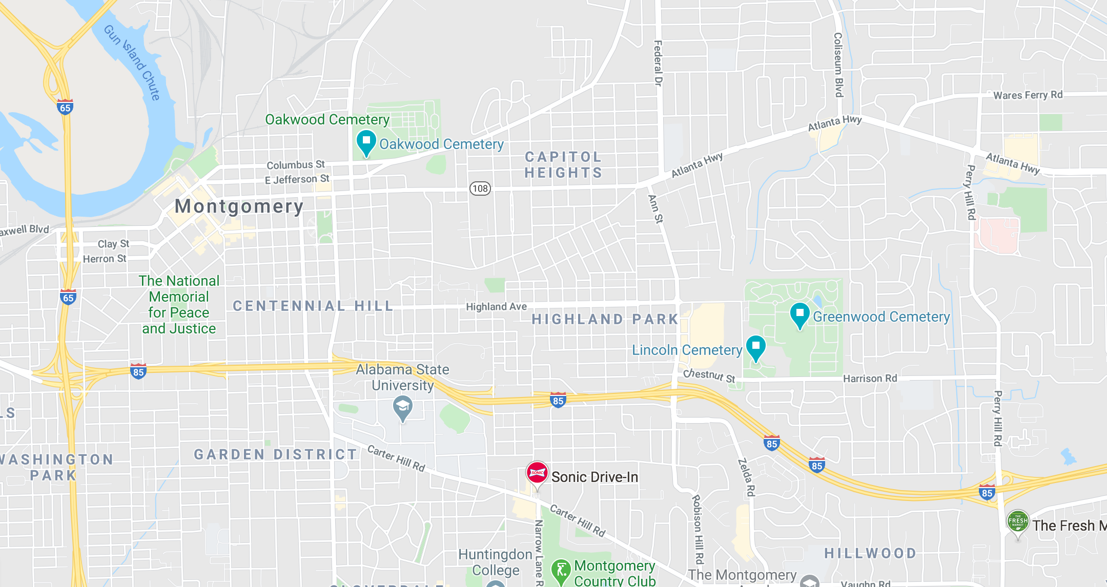
(Image Source: Google Maps)
This map displays where the three focus sites are located. Oakwood Cemetery is in the top left corner, Greenwood Cemetery and Lincoln Cemetery sit side by side on the right side of the map.
Oakwood Cemetery
Oakwood Cemetery, founded in 1819, is the city’s first cemetery. Oakwood cemetery can be found at 829 Columbus St., Montgomery, AL, behind the Montgomery police department. This cemetery is known for its beauty and history as it made the list for one of Alabama’s most beautiful and historically significant cemeteries (Kazek, K. 2017).
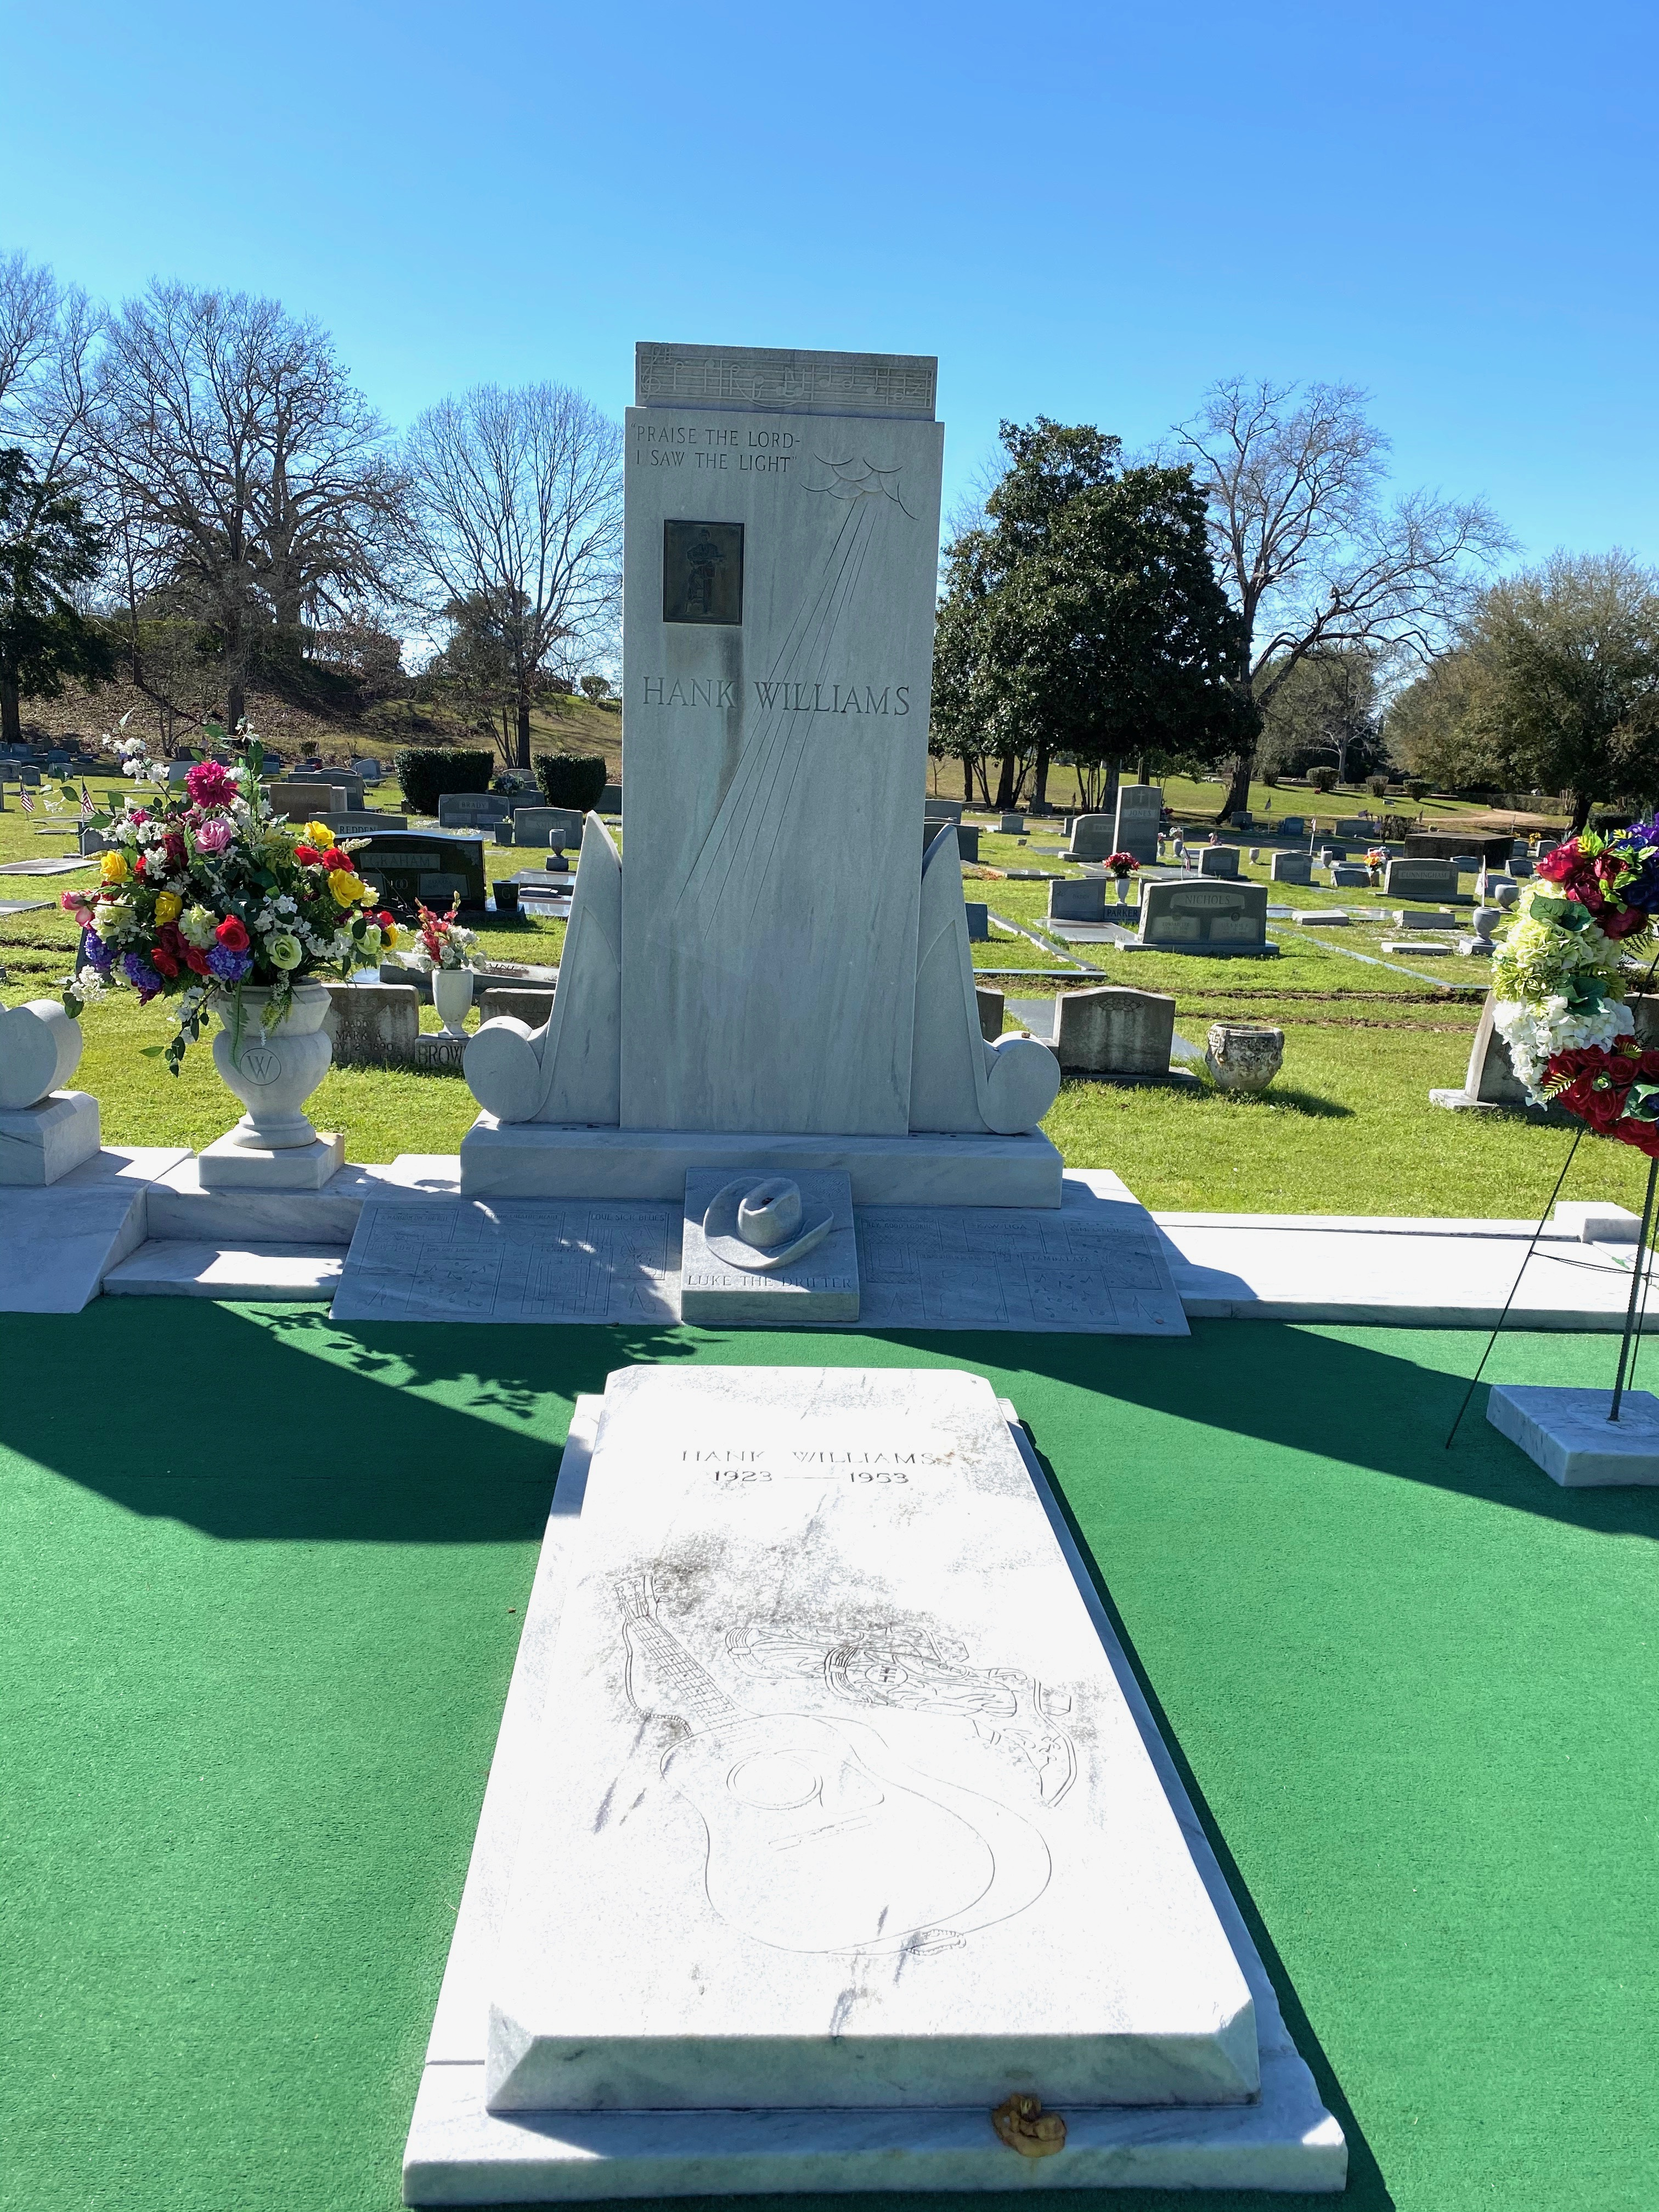
Within Oakwood lies country music legend, Hank Williams. Williams grave is a white marble monument surrounded by green indoor-outdoor (astro-turf) carpeting. This grave features a marble cowboy hat and musical notes and highlights his greatest hits. Of the 130 recordings he made in six years, he had 11 number one (#1) hit singles and 25 others that were in the top ten. Audrey, Williams’s first wife, planned the monument, which includes her grave as well. The monument, designed by Montgomerian Willie Gayle, was unveiled in September 1954, after a two-day tribute to Williams held in Cramton Bowl. The event was attended by ten thousand fans, the stars of country music, and the governors of Tennessee and Louisiana. (Jeff Benton 2015) (Image taken by Michaela Bostick 2020).
Another notable mention for this cemetery is the Sayre family plot. In the Sayre family plot, there is a memory marker in memory of F. Scott Fitzgerald and his wife, Zelda Sayre Fitzgerald. Though the two are not buried here, this is Zelda’s family plot. Also in the Sayre plot lies one of Zelda’s relatives who was the first person to be buried in a metal casket. (Green, T. 2014)
Judge William Parish Chilton, a native of Kentucky, who was Chief Justice of the Alabama Supreme Court and a Confederate congressman and in whose honor Chilton County, Alabama was named, died on January 22, 1871, and was buried in Square 5, Scott’s Free Burial Ground. (Landmarks Foundation p. 30)
These three plots listed above are just a few of some of the historical plots/people that lie within Oakwood Cemetery. See Appendix 3.1 for a more comprehensive list of those buried within Oakwood Cemetery.
Greenwood Cemetery
Greenwood Cemetery, founded in 1901, located at 909 Lincoln Rd., Montgomery, AL, is home to a handful Alabama politicians. One of the most well-known grave sites in this cemetery belongs to George C. Wallace and his wife Lurleen Burns Wallace. George C. Wallace was the 45th Governor of Alabama, he also ran for President of the United States four times, never successfully winning the office. Lurleen Burns Wallace, was the wife and first Lady of Alabama to George C. Wallace. Lurleen also went on to be the 46th Governor of Alabama, right after her husband. (Famous Memorials) (See Appendix 4 for comprehensive list of those buried in Greenwood).
Lincoln Cemetery
Lincoln Cemetery was established in 1907 for African-Americans, but with no one in charge of the cemetery or keeping up with burial records, abuse, vandalism and neglect became rampant and the cemetery was left in disrepair. Lincoln does not have an exact address associated with it, but it can be found at the corner of Lincoln Rd. and Harrison Rd. Lincoln was designed for 700 graves; however, in 2012, volunteers recorded more than nine times that amount, a total of 6,700 graves were found, some of which are actually under nearby roads. In 2010, the City of Montgomery created an authority to restore the cemetery. (Martin, M. 2012)
Lincoln Cemetery is home to Rufus Tee-Tot Payne. Payne was a mentor to Hank Williams Jr. Payne was a native of Lowndes County and a black street singer from whom Williams learned mountain ballads, hymns, ragtime, and jazz. (Jeff Benton 2015) Hugh Carson is buried in Lincoln; he served in the Alabama Legislature during Reconstruction. Ben Moore, whose son named the Ben Moore hotel after him, is buried within Lincoln Cemetery. The Ben Moore hotel is notable as it is one of the places Dr. Martin Luther King Jr. held meetings during the civil rights movement. (See Appendix 5 for Lincoln Cemetery burials and more insight)
Goals
The goal for this interpretation plan is to provide guidance to the visitors and community members of the historical cemeteries in Montgomery. This guidance should allow the visitors to learn the stories of those within the cemetery and how their lives might have been important and significant. The visitor should have the experience of feeling well educated in a friendly environment. Through this plan, the current known history of the historical figures within the cemetery will be told, but the plan creators hope to ignite a light within the visitors that will encourage them to search their own family history and learn more about where they came from. With the visitors doing their own research, family or not, the history they uncover about people within these cemeteries could be used in future guided tours, interpretation kiosk(s), and the interpretation website.
Objectives
- Learn about the history of the cemetery.
- Understand the history, life story, and important influence/significance of the people buried within the cemetery.
- Have the opportunity to interact with the tour guide(s).
- Gain or develop an appreciation for the history of these individuals.
- Want to learn more about the historic individuals.
- Want to attend future interpretive tours.
- Enable visitors to feel comfortable with the interpretive material available to come back and do a self-guided tour with friends and family.
Audiences

- Residents of Montgomery
- School children and teachers across the state
- Youth organizations
- Citizens from outside of Montgomery (domestic and international)
- Historians
- Family members of those in the cemetery
- College and University students
- Professionals in history or other related fields
- General public
Interpretation Proposal
The idea of touring cemeteries is certainly not a new idea. It has been around for quite some time and other cities are using cemetery tours and interpretation as a way to share their history with visitors and the community. Cities such as Atlanta, GA, Charleston, SC, New Orleans LA, Savannah GA, and Richmond, VA are just a few examples of the cities that currently provide a variety of cemetery touring opportunities. The City of Montgomery is no stranger to the touring of cemeteries. In 2018, Mary Ann Neeley gave her last tour of Oakwood Cemetery. Neeley provided years of cemetery tours to the community members and visitors from all over! This interpretation proposal lays out the guidelines to bringing those tours back in a more structured way and even paying tribute to Mary Ann Neely herself!
Development of a cemetery committee
This committee will handle all interpretive materials listed in this proposal. This committee will be appointed by city council or a smaller entity of relevant status should one exist. Term limits will be set for committee members. The committee will work in partnership with local tourism bureau to promote tours and knowledge about cemetery activities and resources within the cemeteries. The committee may also work with historic organizations within the city of Montgomery, such as, Landmarks Foundation of Montgomery Alabama to coordinate historic efforts among the cemeteries. These efforts can include, preservation, tours, clean up, and advertising for upcoming events within the cemeteries.
Development of interpretive cemetery website
Committee members will create and maintain an interpretive website. This website will serve as the platform for how information between the committee and the public should be distributed. This website will contain all cemetery information such as:
    - Cemetery locations
    - Histories of the cemeteries
    - Cemetery maps
    - Dates and times for upcoming tours
    - How to be more involved within the cemeteries (clean up days, volunteers for actors and tour guides, etc.)
    - Agenda and minutes from committee meetings
Install a cemetery marker
At the entrance to each cemetery, a marker shall be placed containing: the name of the cemetery and when it was established. The markers should be somewhat resistant to vandalism and the elements. It will be distinctive, while maintaining the character and integrity of the cemetery. Each marker should hold a significance as to honor those buried within the cemetery it represents. (Appendix 1.1)
Design an interpretation kiosk(s)
There should be small kiosk(s) located throughout the cemetery as to not disturb the cemetery’s atmosphere and design. These kiosk(s) will hold information included but is not limited to:
    - Map of cemetery
    - Family plot locations
    - Historical figures buried within the cemetery
    - Brief histories on the historical figures
    - History of the cemetery
    - Upcoming guided tours
    - Phone number or email address for cemetery committee contact
These kiosk(s) are predicted to be touchscreen as to be more user friendly. They should be able to withstand the elements of nature as they will be placed out in the open environment. (Appendix 1.2)
Install interpretive panels
Interpretive panels will be able to tell stories of the people buried within the cemetery. These panels are not touchscreens and will not be changed or altered frequently. The panels must match the architecture of the cemetery. QR codes will be placed on the panels for visitors to scan; the QR code can navigate the visitor to the interpretive cemetery website. (Appendix 1.3)
Creation of interpretation tours (walking, printed, live)
Walking tours
A walking tour is one of the easiest ways to provide historical context for the cemetery and the people buried within. The walking tours could be free to provide the history and experience to those without the funds to attend the other tours in this plan. The walking tours would be self-guided and would have the chance to take advantage of the use of the interpretation plans and the interpretation kiosks.
Printed walking tours
The traditional self-guided tour usually comes in the form of a brochure with a map and places to stop marked out. Each stop has a short story of the person buried there. This is a great and relatively low-cost option. Install a waterproof brochure holder at the cemeteries and refill the holder on a regular basis so people visiting have access to the brochure right when they walk up. The brochures could include: a map of the cemetery, notable monuments, people, and general information about the cemetery. (Appendix 1.4)
Live character portrayals
Each cemetery should have a guided tour with a knowledgeable tour guide. The tours can be at peak times of the year; such as October for Halloween, May for school field trips, and June for children and organizations that are out of school for summer break. The tours will have up to 15 but no less than 5 stops on the tours. Volunteers will dress as the historical figure, stand next to their grave or tombstone, and tell the story of said person. In between the stops, the tour guides may give brief histories on the cemeteries as a whole, or different parts of the cemeteries as the tour walks through the different sections. (Appendix 1.5)
Creation of a landscape tour
The landscape within cemeteries did not happen by accident, most of it was intentional. This landscape tour will be specifically for Oakwood Cemetery. There are currently trees within Oakwood that are allegedly older than the city of Montgomery. There are old oak trees and cypress trees that have been around hundreds of years. The landscape tour could note these old trees within the cemetery, show special flowers and plants within the cemetery and tell the story of why they are there. There is a theme to why the landscape is the way it is within the cemetery. In the 1800’s there was belief in different ideas of planting certain flowers only at the time of death and for use of funerals. These ideas and beliefs could be more deeply explored and a landscape tour throughout Oakwood Cemetery could be implemented.
Creation of Mary Ann Neeley tribute
Mary Ann Neeley is still well remembered throughout the community. She was the Director of the Landmarks Foundation for quite some time. Neeley gave tours through the Oakwood Cemetery for 20 to 30 years before her passing. She started around the 1980’s doing her own research of the people within the cemetery and their histories. Her tours grew over the years with the last one in 2018. She is now laid to rest in Oakwood Cemetery.
She was a modest a woman but she had an incredible impact on the historic community and the cemetery community. A tribute that could be paid to her is: naming the landscape tour after her, as she loved trees and had even thrown around the idea of a landscape tour, or erecting a bench of some sort near the front entrance of the cemetery. This is the spot where her tours used to gather before starting. A bench that is beautiful in architecture as to match the cemetery but also honoring her memory.
Recommendations
The tour ideas mentioned in the proposal can be expanded upon in many areas. The tours can take place more than just three times a year. There can be tours throughout the years for different time periods of history. Tours honoring: fallen soldiers, politicians, African-Americans, doctors or medical researchers, the tour opportunities are endless but each tour should highlight in a respective manner those that are being mentioned.
The interpretative panels and kiosks should be checked often for maintenance. The panels can be checked every 6 months and minor repairs may be made as needed. The kiosks should be checked once a month for any data or software update that might need to be made to them. The website should be updated frequently, as often as once a month. The website staying up to date will provide the community a sense of reassurance that this website is up and running and the information is up to date.
Data collection needs to take place before implementing parts of this plan. On-site data collection provides a record which can then be entered into an online database, allowing historians, family members, and visitors to locate grave sites remotely. Database options for data collection include: excel spreadsheet, cemetery database software, companies that input and manage data, build your own online database website, crowdsource databases- find a grave (.com) or billion graves (.com). (Appendix 2.1 and 2.2)

Budget
The care of Oakwood cemetery is the responsibility of the City of Montgomery and the cemetery is operated and maintained from the General Fund under the supervision of the City Maintenance Department (Old Oakwood Cemetery pg. 12). Lincoln cemetery was given money for restoration and clean-up of the cemetery. Greenwood cemetery is undetermined how their funding is received if any funding is received at all (currently).
The budget is laid out below. There are ways within this budget to cut some of the costs. For the website, if the committee would like to save that money and put it towards another area, there are a handful of colleges around Montgomery in which the committee could enlist the help of some students to create the website for free. The students could get class credit or it could be a competition on the winner wins a scholarship or cash prize. This could save money on website creation while not cutting cost on an efficient website.
While there is not an abundance of cemetery grants, there are a few that the committee could look into. These grants could help with the upkeep of the cemeteries or even go towards something as simple as cemetery markers. The money from the grants will help cut down on the budget while still providing the funds for specific areas of need.
The tours could provide an opportunity to make money, the money made from the tours could go into a general fund that is used to do small repairs at the cemeteries or even saved over time to invest in new kiosks or panels. If the tours cost $5 for adults and $2 for children, this money could add up quickly and if the tours are constant, this would always be an income of money for the cemeteries as long as the tours are being utilized.

Cemetery Interpretation Plan Budget
Item | Cost
Committee | Free
Website | $15,000
Cemetery Markers (3) | $1,500
Interpretation Kiosk(s) (3) | $30,000
Interpretation panels (3) | $10,000
Printed tours brochure | $1,500
Character tours | Free
Landscape tours | Free
Mary Ann Neeley tribute | $1,500
Total: | $59,500

Conclusion
The cemeteries within Montgomery, Alabama hold so much history that should be remembered and talked about. This plan lays out the foundation for the city to become more involved with interpreting the history that lies within these cemeteries to share with anyone who would like to hear it.

Appendices
These appendices are not intended to be definitive or prescriptive, but are instead a gathering of information and ideas to inform detailed planning and implementation during the delivery phase.
Appendix 1 - Interpretation examples
Appendix 2 - Recommendations
Appendix 3 - Oakwood Cemetery Notable Graves
Appendix 4 – Greenwood Notable Graves
Appendix 5 – Lincoln Notable Graves
Appendix 6 – List of Montgomery, AL cemeteries

Appendix 1- Interpretation examples

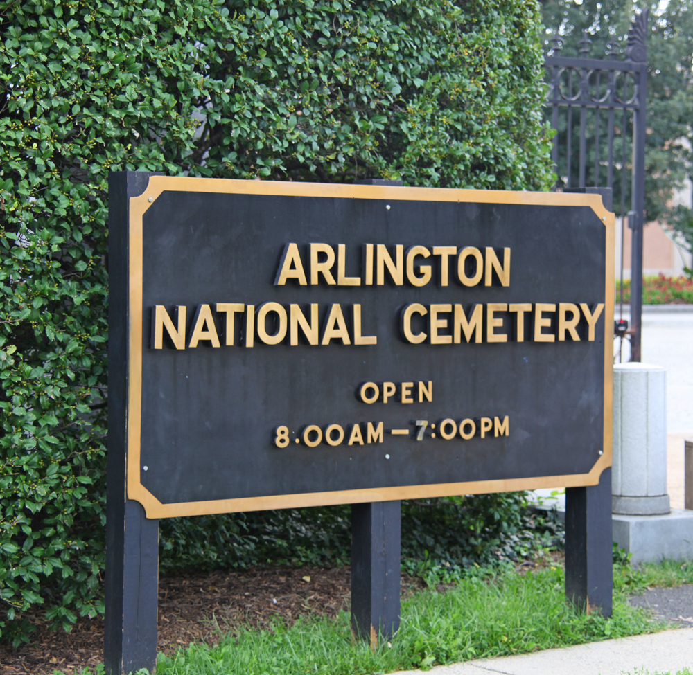
Appendix 1.1
Cemetery Markers- an example from Arlington Nation Cemetery for the cemetery markers. These markers are meant to be discrete and tasteful while being able to withstand the conditions of the natural elements. (Image source: Nick. 2019, August 2)

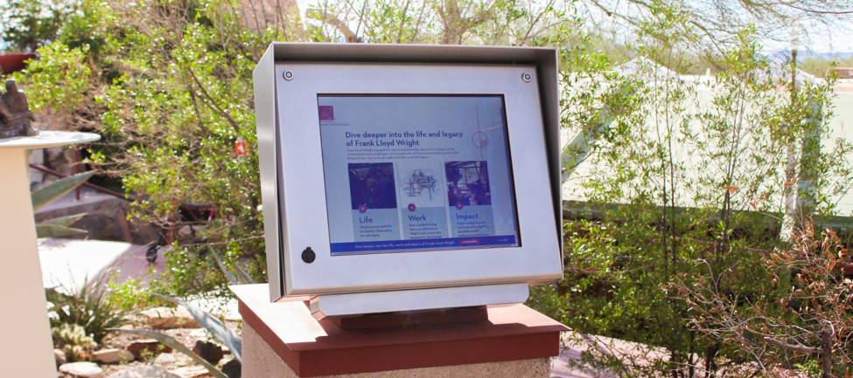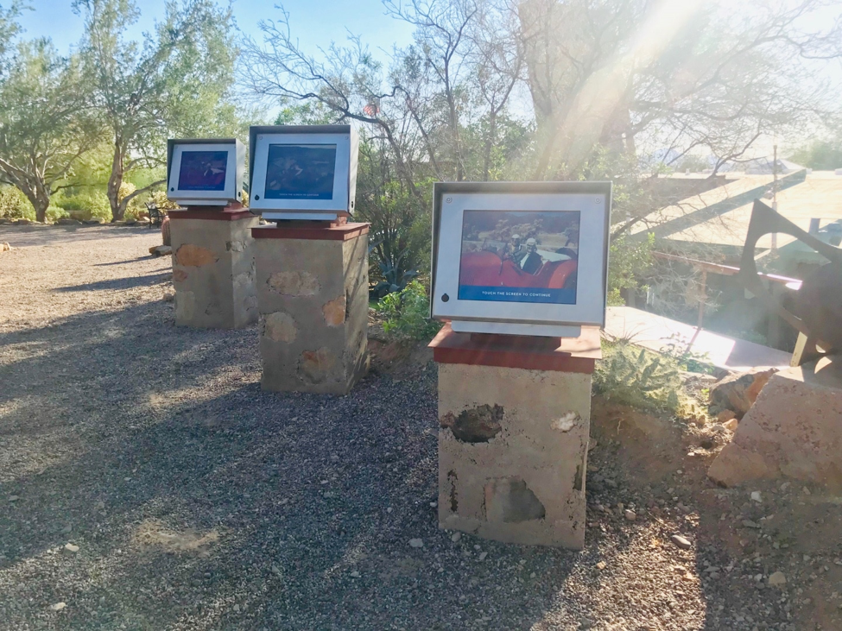
Appendix 1.2
Interpretation Kiosks- These image reflect examples of interpretation kiosks from the Frank Lloyd Wright Museum. These are touchscreen and interactive for the visitors. There are heavy duty to ensure they can withstand the elements while still matching the architecture of the museum they are in. (Image Source: Digital Interpretive Kiosks Now Open to Public at Taliesin West. 2018, November 8)

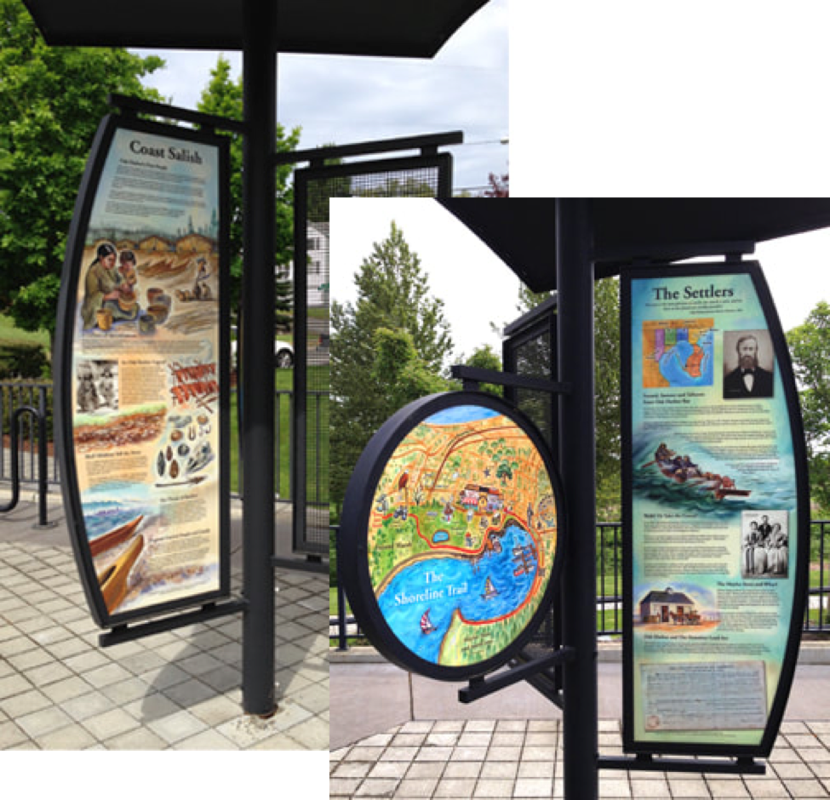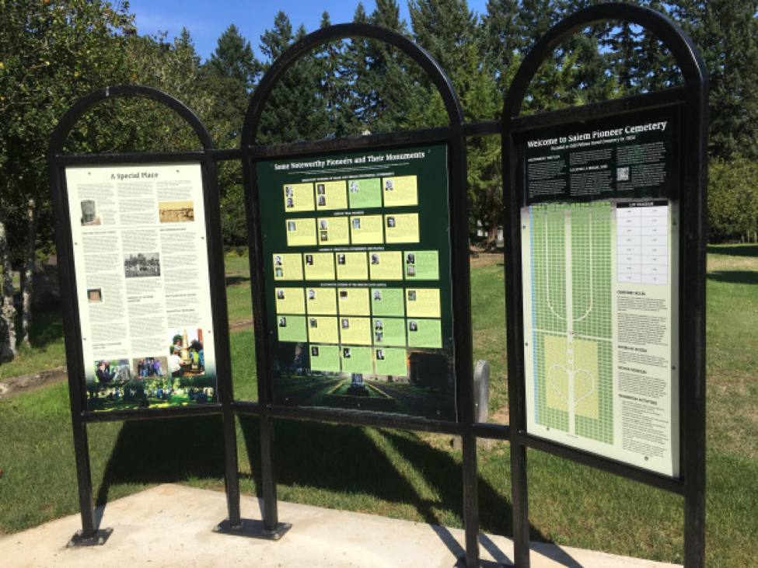

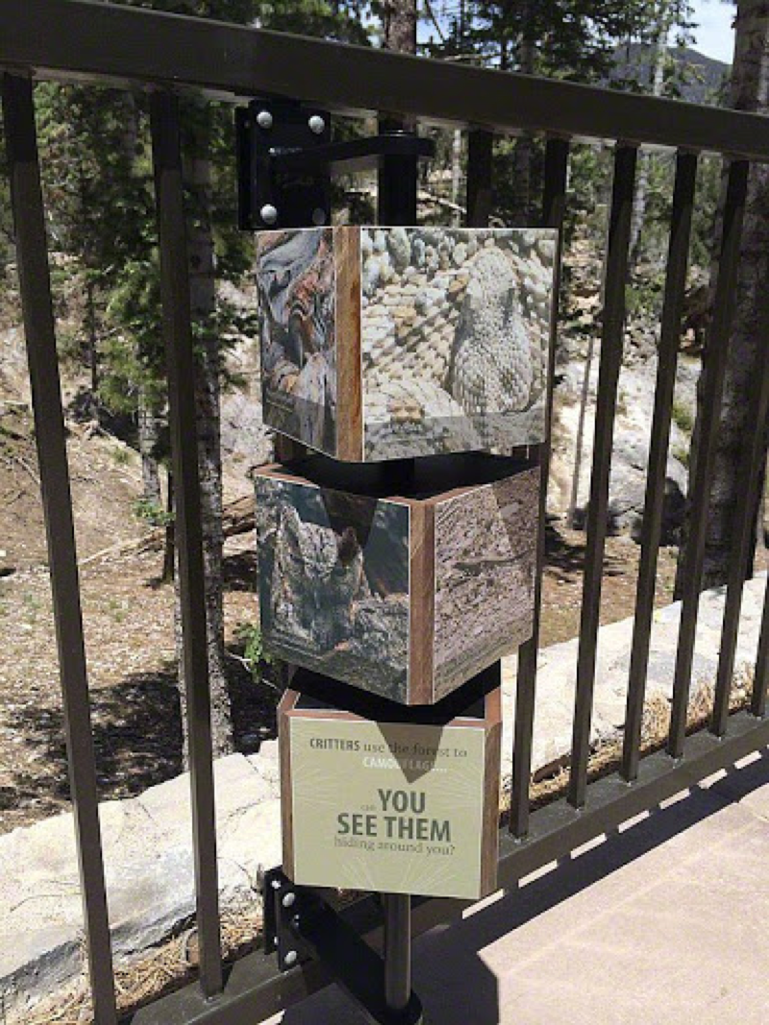
Appendix 1.3
Interpretive Panels- The above images are examples of interpretive panels. These panels display maps of the cemetery, information about people who are buried within the cemetery, history of the cemetery, and landscaping around the cemetery. (Image Sources: Interpretive Panels. 2018, April 30) and (Interpretive Signs. (n.d.)

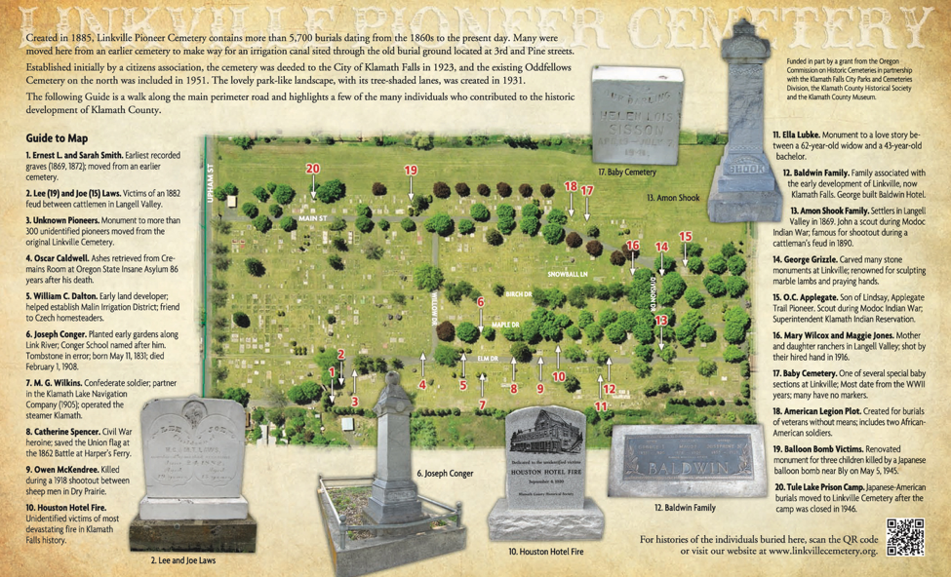
Appendix 1.4
Printed Walking Tour- This image is an example of what the walking tour brochure could look like. There would be a map of the cemetery with a guide of the different grave sites to visit with a brief history associated with each. The QR code in the bottom right corner of the brochure could send the visitor directly to the interpretive website for more information should they desire it. (Image Source: Brochure Highlights Linkville Cemetery History. 2014, February 21)

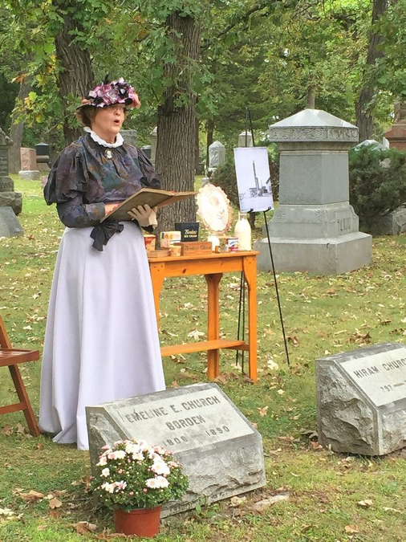
Appendix 1.5
Live Character Portrayal
(Image Source: Rohr, L. 2015, September 28).

Appendix 2- Recommendations

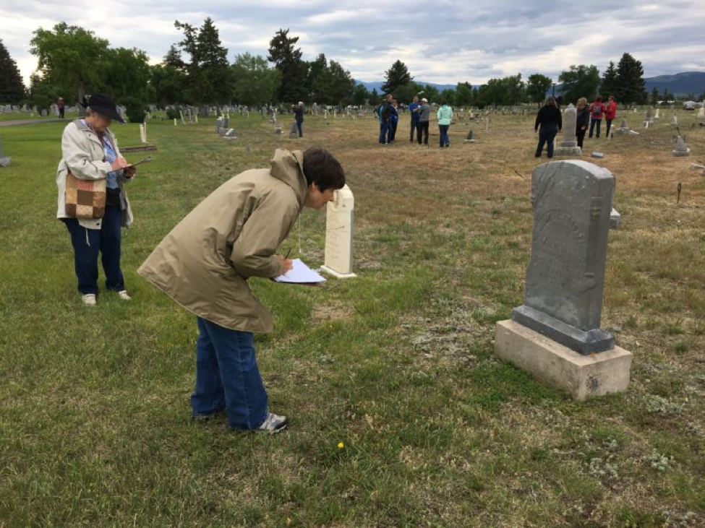
Appendix 2.1
Data Collection- This image represents an example of volunteers gathering the information on the grave stones such as name, date of birth and death, any quotes, and where the person is located within the cemetery. (Image Source: unknown)

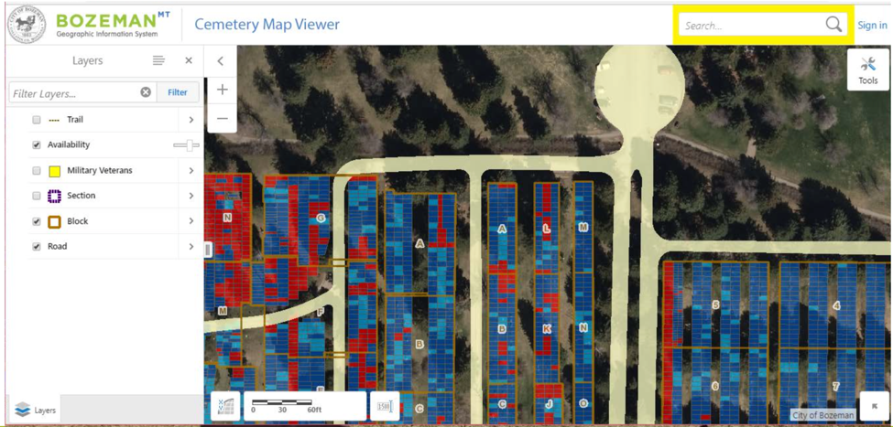
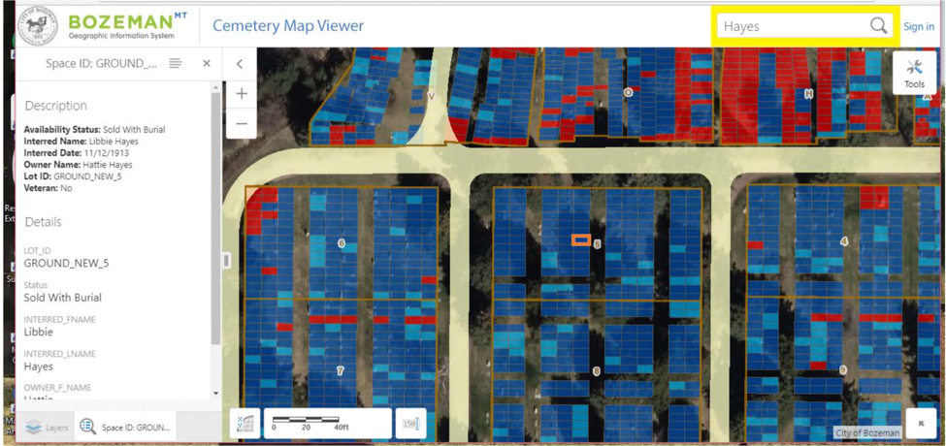
Appendix 2.2
Data Collection GIS- These images above show an example of how the data from appendix 2.1 can be put into an online database. This can be used to find specific locations within the cemetery and can also be used when making maps for panels, website, or brochures. (Image Source: Bozeman website)
Appendix 3- Oakwood Cemetery Notable Graves
The list of names below is not intended to exclude any individuals who may lie in rest within Oakwood Cemetery. This list is only a small portion of the significant individuals that lie within. (All names listed below from source: Landmarks Foundation (2001) p. 29-37)

Appendix 3.1 - Names

Dr. William O. Baldwin
Dr. Carnot Bellinger
Nimrod Earle Benson
Benajah Smith Bibb
Sophia Gilmer Bibb
Captain Abraham Calvin Caffey
Judge William Parrish Chilton
Major General James Holt Clanton
Judge David Clopton
The Right Reverend Nicholas Hamner Cobbs
Mrs. Charlotte Morton Dexter
General Elisha Y. Fair
John Falconer
Governor Benjamin J. Fitzpatrick
Brigadier General Birkett Davenport Fry
John Gindrat
George Goldthwaite
Mrs. Sarah Bozier Hails
James Hale
Colonel Hilary A. Herbert
Sarah Parker Herron
Rev. Luther Leonidas Hill
Henry Washington Hilliard
Lucy Holt
General James Thaddeus Holtzclaw
William Burr Howell
General Crawford M. Jackson
Governor Thomas Goode Jones
Colonel Robert Fulwood Ligon
Colonel Tennant Lomax
Reverend George Gray McWhorter
Josiah Morris
Governor William C. Oates
Dr. Samuel Clark Oliver
Albert James Pickett
Charles Teed Pollard I
Monsignor Dennis Savage
Justice Anthony D. Sayre
Eliza Huxley Scott
Major Henry Churchill Semple
Colonel John Jacobs Seibels
Reverend Dr. Horace Stringfellow
Jack Thorington
Victor H. Tulane
Colonel Robert Tyler
Justice Abram Joseph Walker
Governor Thomas Hill Watts
Joseph S. P. Winter
William Lowndes Yancey

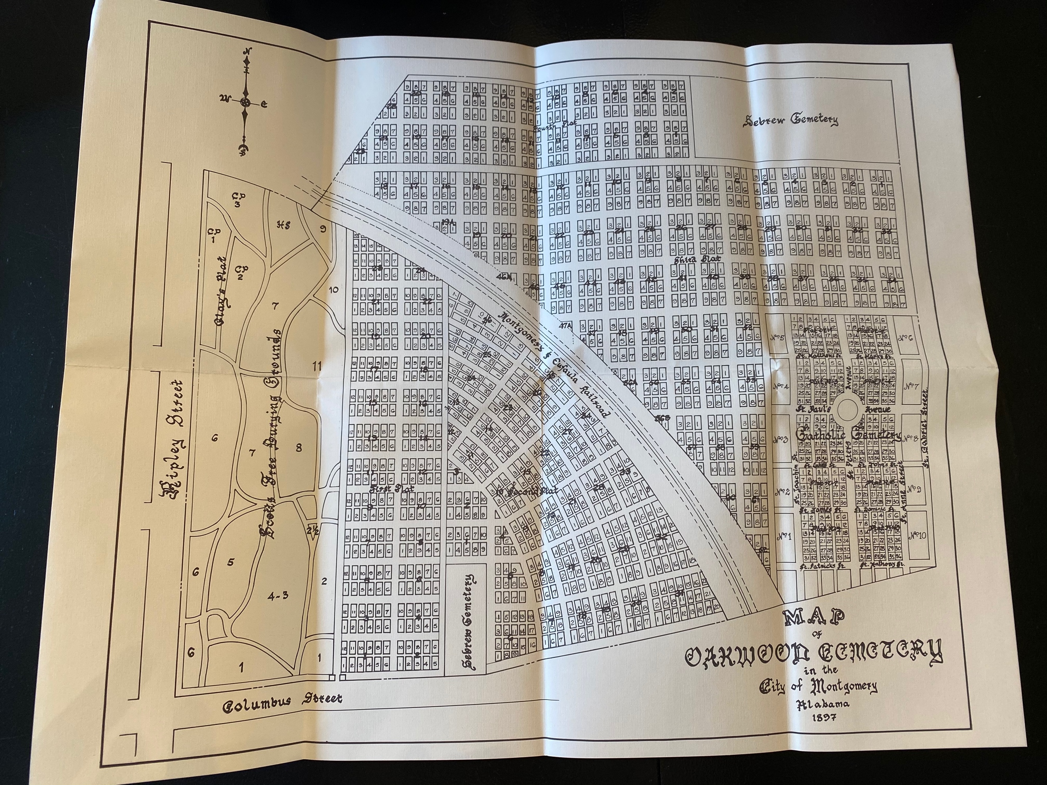
Appendix 3.2
Map of Oakwood Cemetery. Image taken by Michaela Bostick

Appendix 4 – Greenwood Notable Graves
The list of names below is not intended to exclude any individuals who may lie in rest within Greenwood Cemetery. This list is only a small portion of the significant individuals that lie within.
Appendix 4.1 – Names
John Abercrombie (U.S. Congressman)
Johnnie Carr (Civil Rights leader)
Bibb Graves (38th Governor of AL)
Dixie Bibb Graves (U.S. Senator & First Lady of AL)
J. Lister Hill (U.S. Congressman & Senator)
Reuben Kolb (AL’s Commissioner of Agriculture)
William R. Lawley Jr. (U.S. Army Air Forces Officer & Medal of Honor recipient)
Gordon Persons (43rd Governor of AL)
John C.C. Sanders (Civil War Confederate Brigadier General)
George Wallace (45th Governor of AL)
Lurleen B. Wallace (46th Governor of AL & First Lady of AL)

Appendix 5 – Lincoln Notable Graves
The list of names below is not intended to exclude any individuals who may lie in rest within Lincoln Cemetery. This list is only a small portion of the significant individuals that lie within.

Appendix 5.1 – Names
Hugh Carson (AL Legislature during Reconstruction)
Aurelia Browder- Coleman (Friend of Rosa Parks & lead plaintiff in historic court case: Browder v. Gayle)
Ben Moore (Ben Moore Hotel named after him by his son)
Rufus “Tee-Tot” Payne (mentor to Hank Williams)

Appendix 5.2 – Lincoln explanation
Lincoln cemetery was not under direct supervision until recently. There was not a system in place for how people were laid to rest or even plot sizes. In recent years, researchers have found that the graves were extremely close together, and a large amount remained unmarked. There could be tons of history buried within Lincoln but without markers or documentation it is hard to know exactly who is buried here and where.

Appendix 6 – List of Montgomery, AL cemeteries

Appendix 6.1 - Compliant Cemeteries

Brassell
Big Roxanna Missionary Baptist Church Cemetery
Davis Family Cemetery
Eastwood Memorial Gardens
Eternal Rest
Greenwood
Garrison Cemetery
Kindle Cemetery
Macedonia Missionary Baptist Church Cemetery
Madison Cemetery (Hunter Station)
Madison Park Memorial Cemetery
Montgomery Memorial
Mountain Hill Baptist Church
Mount Mariah A.M.E. Zion Church Cemetery
New Canaan Baptist Church
Oakwood Annex
Old Elam Cemetery
Oakwood St. Margarets
Old Oakwood Cemetery
Robinson Cemetery
Woodley Memorial Gardens
William Lockhart Cemetery (Marshall)

Appendix 6.2 - Non-Compliant Cemeteries

Abner McGehee Cemetery
Dixon Gravesite
Barachias Cemetery (Jones)
Willis Brewer Mausoleum
Flora Cemetery
Harper
Harris (Evergreen)
Larkin Cemetery
Lincoln
McLemore-Taylor Cemetery
Remount Cemetery
Ware (Seibles Cemetery)
Ware - Green Cemetery
Westcott Cemetery
Winfrey Oliver Place (Brown)

Appendix 6.3 - Compliance
The requirements for a cemetery to be in compliance are as follows:
- The cemetery must have a sexton.
- The cemetery must have a business license with the City of Montgomery.
- The cemetery must have good records.
- The cemetery must have a map showing the grave spaces already used and the grave spaces that are available for future interments.
- The cemetery must have proper maintenance.
(City of Montgomery. (n.d.).)

Sources

Benton, J. 2015. Oakwood Cemetery tours. (Email)

Brochure Highlights Linkville Cemetery History. (2014, February 21). Retrieved from
https://oregonheritage.wordpress.com/2014/02/21/brochure-highlights-linkville-
cemetery-history/
City of Montgomery. (n.d.). Retrieved from https://www.montgomeryal.gov/play/explore-
montgomery/cemeteries
Digital Interpretive Kiosks Now Open to Public at Taliesin West. (2018, November 8). Retrieved
from https://franklloydwright.org/digital-interpretive-kiosks-now-open-to-public-at-
taliesin-west/
Famous Memorials - Find A Grave Cemetery. (n.d.). Retrieved from
https://www.findagrave.com/cemetery/23137/famous-memorials?page=1#sr-6404438
Greene, T. (2014, March 10). Oakwood Cemetery: Tales to be told. Retrieved from
https://www.montgomeryadvertiser.com/story/news/local/2014/03/10/oakwood-
cemetery-tales-to-be-told/6249027/
Interpretive Panels. (2018, April 30). Retrieved from
https://publichistoryofcemeteries.org/outdoor-museums/interpreting-the-
past/interpretive-panels/

Interpretive Signs. (n.d.). Retrieved from https://www.kriswiltse.com/interpretive-signs.html

Kazek, K. (2017, September 18). 11 beautiful, historically important Alabama cemeteries.
Retrieved from
https://www.al.com/living/2017/09/11_of_alabamas_most_beautiful.html
Landmarks Foundation. (2001). Old Oakwood Cemetery. Montgomery, AL.
Martin, M. (2012, August 9). Uncovering Secrets Buried At A Neglected Cemetery. Retrieved
from https://www.npr.org/2012/08/09/158428314/uncovering-secrets-buried-at-a-
neglected-cemetery
Nick. (2019, August 2). Visiting Arlington National Cemetery. Retrieved from
https://ambitionearth.com/visiting-arlington-national-cemetery/
Rohr, L. (2015, September 28). Annual cemetery walk features stories of Elgins origin.
Retrieved from https://www.dailyherald.com/article/20150927/news/150928879/

